**How to config Netflow monitor**

DOCUMENT VERSION HISTORY

|  |  |  |  |
| --- | --- | --- | --- |
| VERSION | DATE | DESCRIPTION | AUTHOR/EDITOR |
| 0.9 | 10/01/2024 | 1st. version | Jacky.zou, Spencer.hung  Nickle.Wu, Double.lin |

Contents

1 Configure flowview monitor 2

1.1 Configure flowview generator simulator 2

1.2 Configure listeners 4

1.3 Configure filters 5

1.4 Statistical Report 6

1.5 Check DB size & Row numbers 6

1.6 Sample flow export configuration on Cisco SW & Fortigate 6

# Configure flowview monitor

Steps: Configure Netflow Generator (simulator) Listener => Configure filter => view flow status

## Configure flowview generator simulator

Download and Configure NetFlow Generator to create test flow source traffic on UDP port 9099, version 9

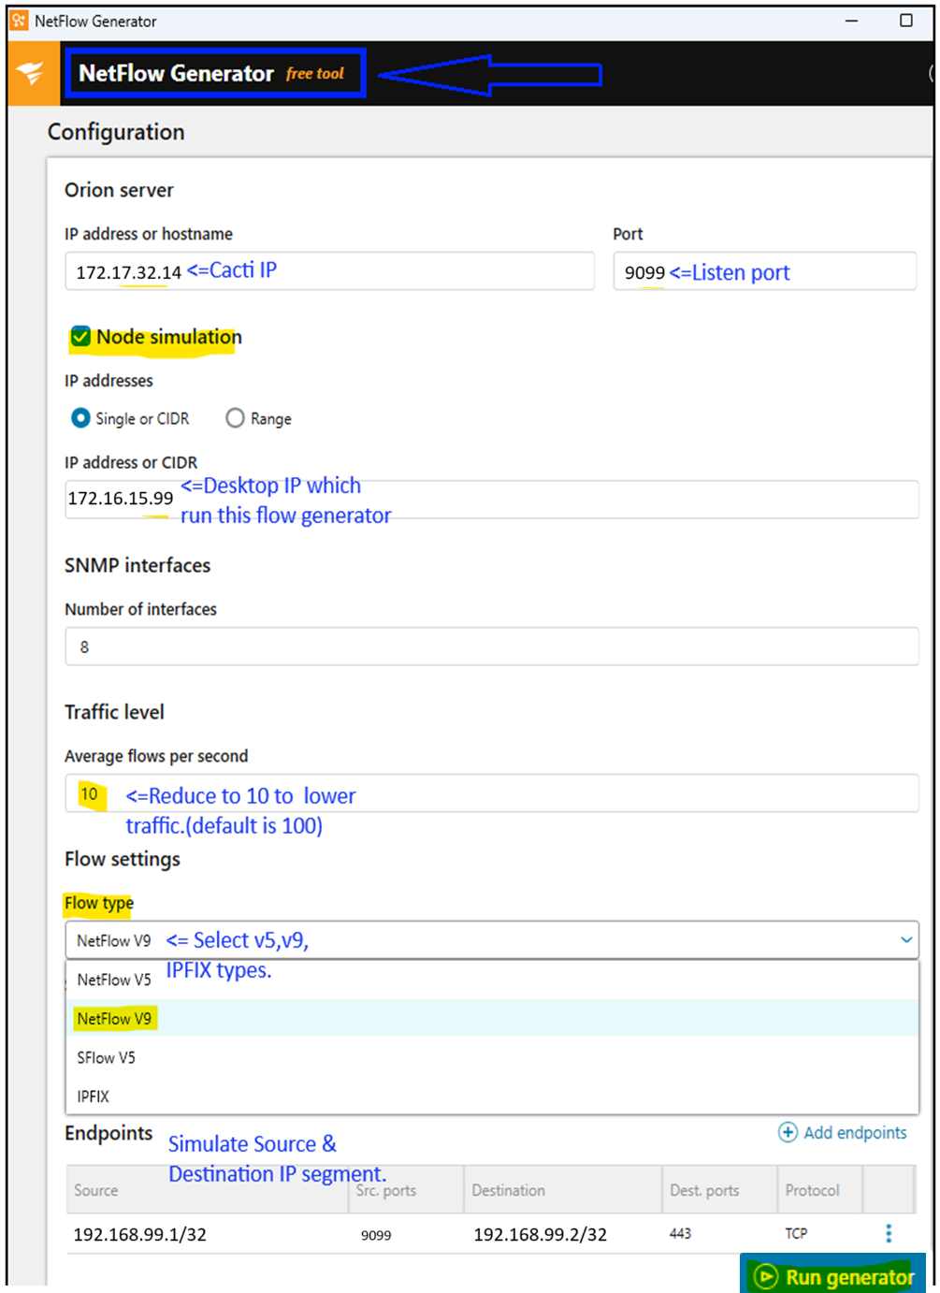  
Start generating flow v9 traffics…

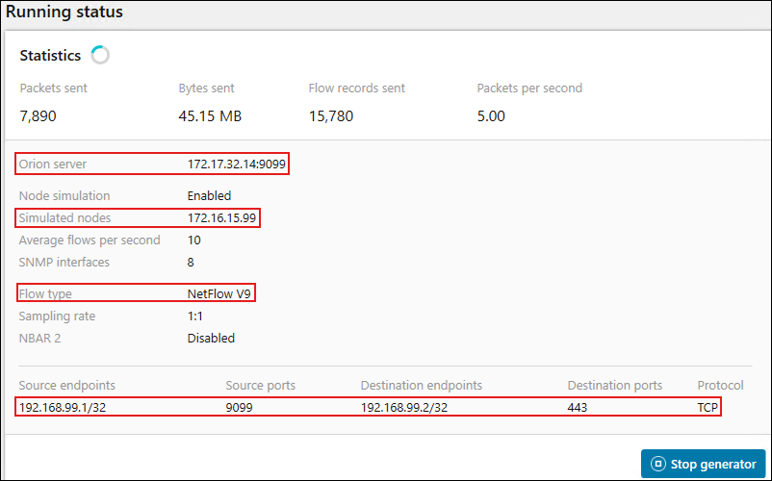

## Configure listeners

Configure folwview generator to create test flow traffic on UDP port 9099 (v9)

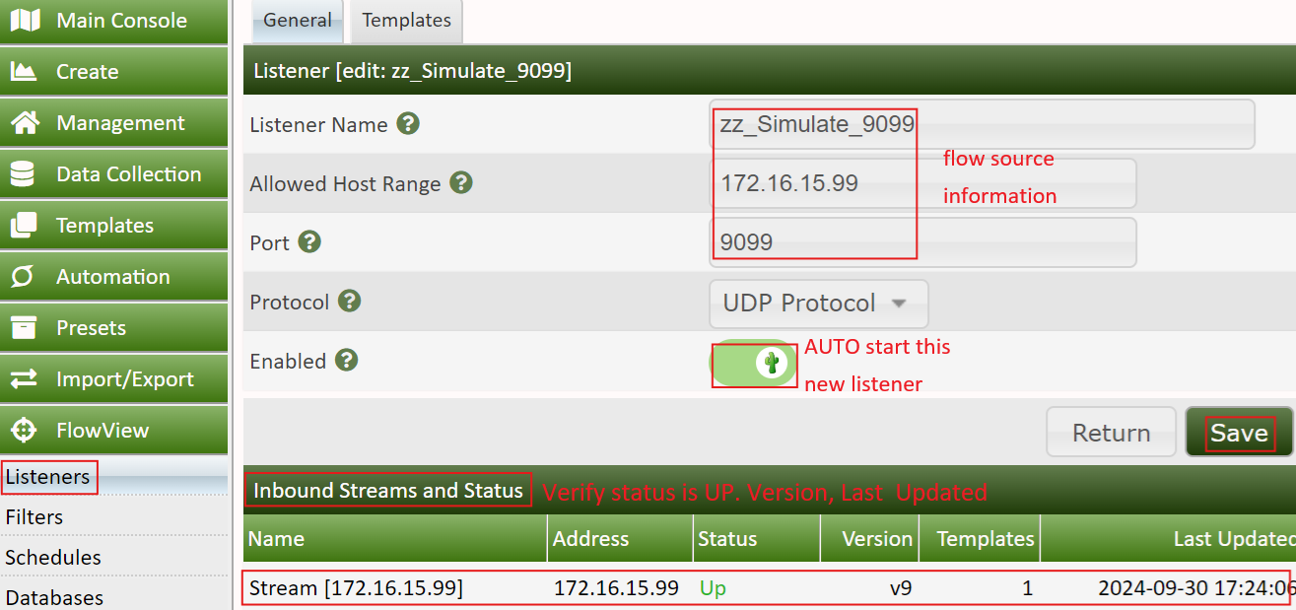

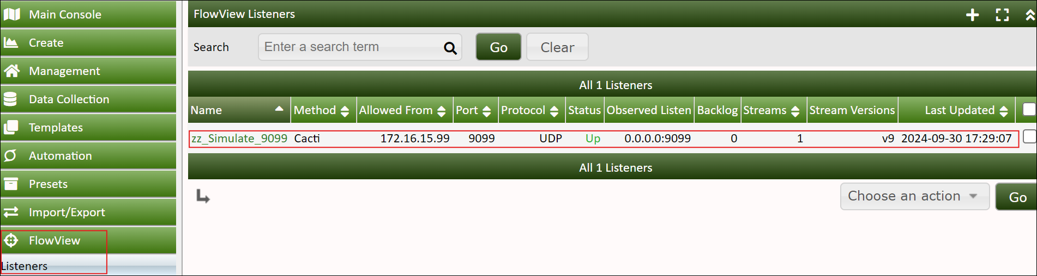

systemctl status flow-capture

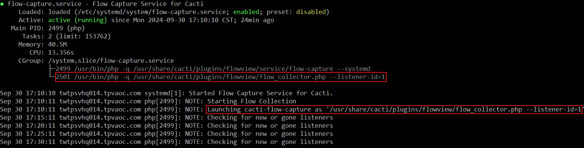

## Configure filters

Create filters map to listeners, “Stream Address” IP & Max. Row “Top 15” must be assigned to increase stability.   
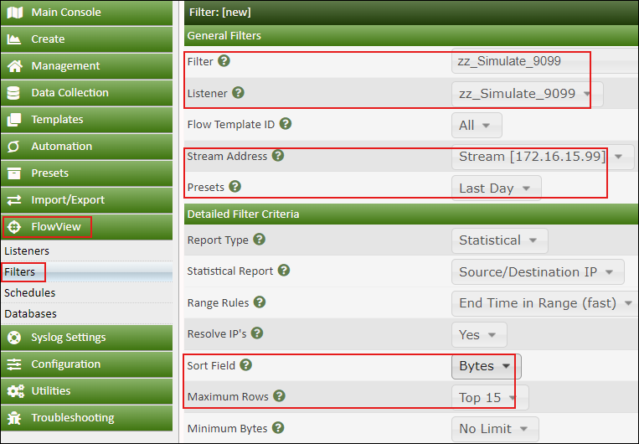  
Result

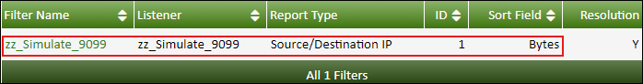

## Statistical Report

Click “FlowView” => Select Filter & Listener => Click “GO” => Click “Table”  
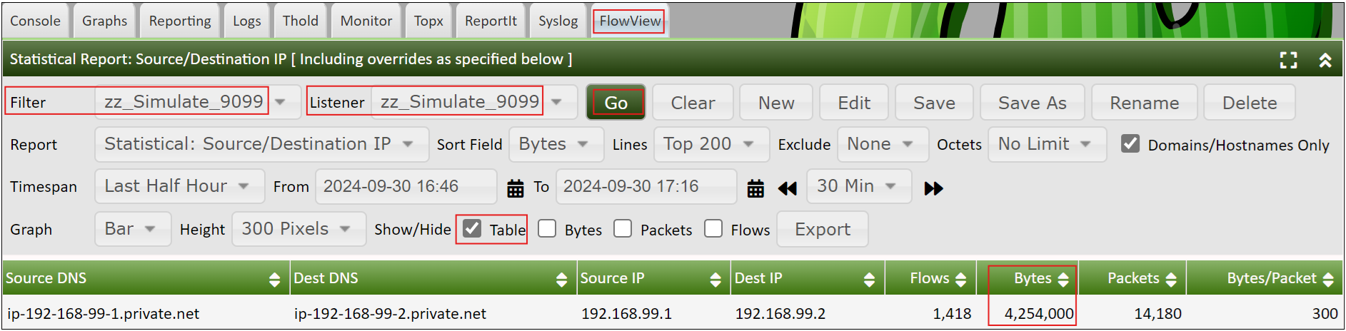

## Check DB size & Row numbers

#Show flowview DB table size & row number

mysql -uroot -e "SELECT t.table_name AS \`Table\`, ROUND(((t.data_length + t.index_length) / 1024 / 1024), 2) AS \`Size (MB)\`, t.table_rows AS \`Rows\` FROM information_schema.tables t WHERE t.table_schema = 'flowview' ORDER BY (t.data_length + t.index_length) DESC;"

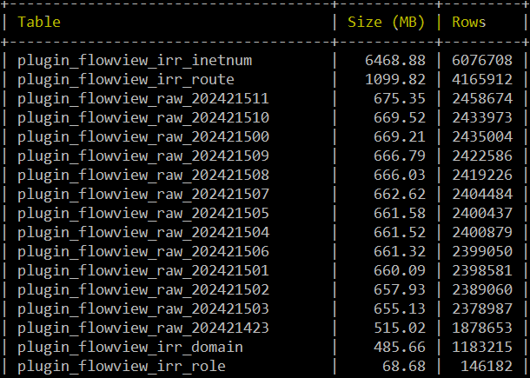

## Sample flow export configuration on Cisco SW & Fortigate

***Cisco Switch:***

flow record TPV-Flow-Record

match ipv4 destination address

match ipv4 source address

match transport source-port

match transport destination-port

match ipv4 protocol

match interface input

match ipv4 tos

match flow direction

collect counter bytes long

collect counter packets long

collect transport tcp flags

collect timestamp absolute first

collect timestamp absolute last

collect interface output

!

!

flow record TPV-Flow-Record-OUT

match ipv4 destination address

match ipv4 source address

match transport source-port

match transport destination-port

match ipv4 protocol

match interface output

match ipv4 tos

match flow direction

collect counter bytes long

collect counter packets long

collect transport tcp flags

collect timestamp absolute first

collect timestamp absolute last

collect interface input

!

!

flow exporter FNFexp

destination 172.17.32.16

source Vlan99

transport udp 2055

!

!

flow exporter test

destination 172.17.32.14

source Vlan99

transport udp 2055

!

!

flow monitor FlowMonitor1

exporter FNFexp

exporter test

record TPV-Flow-Record

!

!

flow monitor FlowMonitorOUT

exporter FNFexp

exporter test

record TPV-Flow-Record-OUT

!

!

sampler sampler1

description sample at 50%

mode random 1 out-of 2

!

!

interface GigabitEthernet1/1/2

switchport trunk allowed vlan 99

switchport mode trunk

ip flow monitor FlowMonitor1 sampler sampler1 input

ip flow monitor FlowMonitorOUT sampler sampler1 output

channel-group 2 mode active

interface GigabitEthernet2/1/2

switchport trunk allowed vlan 99

switchport mode trunk

ip flow monitor FlowMonitor1 **sampler sampler1** input

ip flow monitor FlowMonitorOUT **sampler sampler1** output

channel-group 2 mode active

***Fortigate Firewall:***

FG3H1E5819903613 (global) # show system netflow

config system netflow

    set collector-ip 172.17.32.14

    set collector-port 9005

    set source-ip 172.17.32.100

    set active-flow-timeout 60

    set inactive-flow-timeout 10

end

FG3H1E5819903613 (global) # show system interface "port3"

config system interface

    edit "port3"

        set vdom "root"

        set ip 172.17.32.100 255.255.255.0

        set allowaccess ping https snmp

        set type physical

**set netflow-sampler both**

**set sflow-sampler enable**

**set sample-rate 50**

        set explicit-web-proxy enable

        set description "LAN"

        set alias "lan"

        set device-identification enable

        set role lan

        set snmp-index 5

    next

end